1. How wide a variance is noticeable in the final year-end price of the stock for the 5 separate trials performed through steps IV and V? Analyze and draw your conclusions.

Considering the results below, one can consider the variance wide, the 5 separate trial had results in which the i3 case was approximately 100% higher than the i2 case. Considering that each trial has the same mean, the variance is wide.

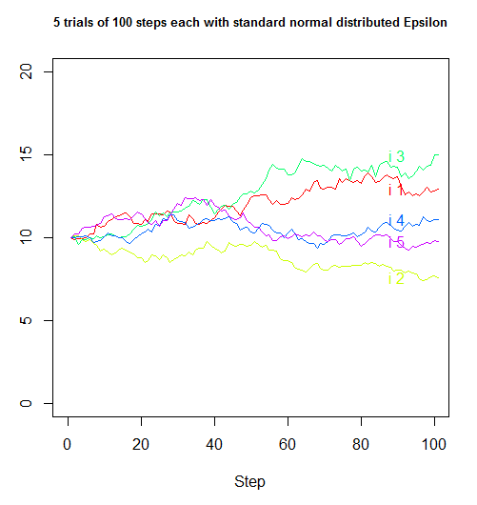

1. Would the variance been higher if ε was assigned purely on a random basis from an arbitrary distribution?

No, the variance would NOT been higher due to the central limit theorem. The Central Limit Theorem establishes that, for the most commonly studied scenarios, when [independent random variables](https://en.wikipedia.org/wiki/Statistical_independence) are added, their sum tends toward a [normal distribution](https://en.wikipedia.org/wiki/Normal_distribution) (commonly known as a bell curve) even if the original variables themselves are not normally distributed. In more precise terms, given certain conditions, the [arithmetic mean](https://en.wikipedia.org/wiki/Arithmetic_mean) of a sufficiently large number of iterates of independent random variables, each with a well-defined (finite) [expected value](https://en.wikipedia.org/wiki/Expected_value) and finite [variance](https://en.wikipedia.org/wiki/Variance), will be approximately [normally distributed](https://en.wikipedia.org/wiki/Normal_distribution), regardless of the underlying distribution.